Home Inventory (Sample App)

This application will manage the records of home items in order to do an eventual claim to insurance companies.

There will be a list with the following filters:

Model, Serial Number, Location, Description.

The list must implement sorting and paging. The Default Sort is by Description Ascendant.

The items in the Purchase Info column must be implemented in a partial view like the example of Partial Views reviewed in class.

Only the list, creation, deletion and see details functionalities must be implemented.

The creation of a Home Item must be implemented using a ViewModel class. The View model will have the following fields: HomeItemId, Model, SerialNumber, LocationId, Location, Description, Photo(HttpPostedFileBase) , When, Where, Warranty and Price fields. **Hint:** You can create your ViewModel then scaffold it only to generate the “Create” view.

**View Hint:** In the “Create” view, you need to define the “Photo” field as follows:

<input type="file" name="Photo" accept="image/x-png,image/gif,image/jpeg" required />

Also, The @Html.BeginForm Action must be defined as follows:

Html.BeginForm("Create", "HomeItems",FormMethod.Post, new { @enctype= "multipart/form-data" })

This will allow you to post the photo using your ViewModel.

The list will look like this without filters. You need to add the filters and sorting capabilities as well.

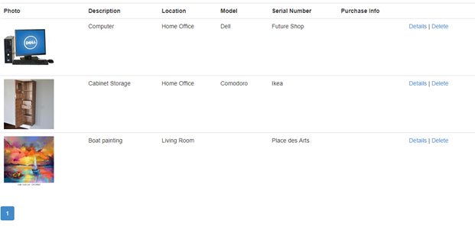

The Details page will look like this but in addition to the Purchase Info information. In addition, in the delete page, it will appear the image with size **W:** 300 **H:** 300. The teacher will provide the image handling.

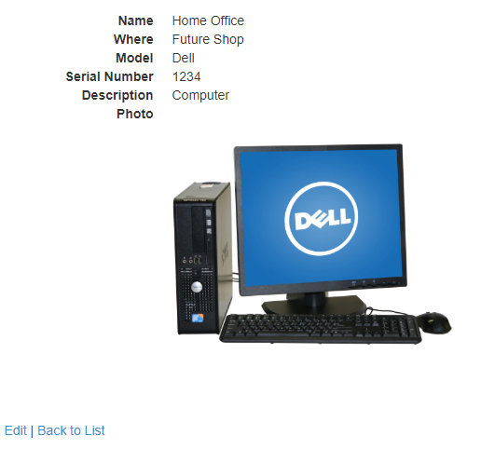

Note: The teacher will provide the helper classes needed to show images from the database and the ones to convert a posted file into a byte array.

The tables are defined as follows:

|  |  |  |
| --- | --- | --- |
| HomeItem | | |
| HomeItemId | Int (int) | Primary key |
| Model | NVarchar(100) (string) | Null |
| SerialNumber | NVarchar100) | Null |
| LocationId | Int | Not Null (foreign key) |
| PurchaseInfoId | Int | Not Null(foreign key) |
| Description | NVarchar(255) | Not Null |
| Photo | VarBinary(max) | Null |

|  |  |  |
| --- | --- | --- |
| PurchaseInfoes (name generated by EF) | | |
| PurchaseInfoId | Int | Primary Key |
| When | DateTime | Null |
| Where | NVarchar(255) | Null |
| Warranty | NVarchar(255) | Null |
| Price | Decimal | Null |

|  |  |  |
| --- | --- | --- |
| Locations | | |
| LocationId | Int | Primary Key |
| Name | VarChar(Max) | Not Null |